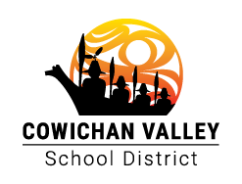

Framework for Enhancing Student Learning School Plan
DRINKWATER ELEMENTARY SCHOOL 2026/2027

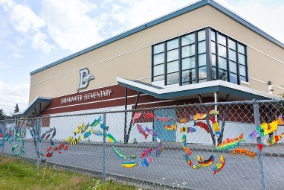

Uy' Skweyul Siiem nu siiye’yu. Uy’ nu shqwuluwun kwunus ‘i lumnalu. Good day my respected friends. It is good to see all of you.

Our Story
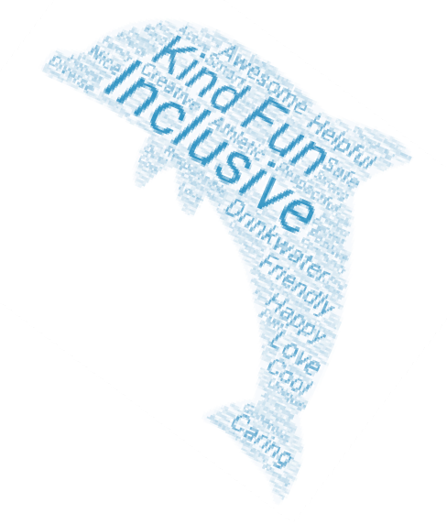

Drinkwater Elementary is a Kindergarten to Grade 7 school situated in North Cowichan, within the community of Duncan. In the 2026–2027 school year, we are proud to serve 367 students across 18 divisions, the majority of which are organized in multi-grade classrooms. Our school has long been an important part of the Cowichan Valley and is located on the unceded traditional territory of the Quw’utsun people. We acknowledge this with gratitude and recognize the privilege of learning, working, and growing together on this land, surrounded by vibrant neighbourhoods, forested areas, and local waterways.

Located in a primarily residential neighbourhood, many of our students travel to school on foot, by bike, or by scooter. Outside of school hours, our grounds are lively with families gathering at the playground and fields, reflecting our role as a true community hub. Drinkwater provides both before- and after-school care to support working families, as well as a Strong Start early learning program that welcomes young children and their caregivers, helping to build confidence and readiness for entry into school. Our school community reflects a wide range of cultural, linguistic, and socio-economic backgrounds, and we value the richness this diversity brings. We intentionally foster an environment where students and families feel a strong sense of belonging and connection.

During outdoor play, students have many opportunities to be active, creative, and have fun. They can enjoy organized sports such as soccer, football, baseball, volleyball, basketball, and floor hockey. Students can also explore our natural areas, play in the outdoor kitchen, build in the sandbox, create chalk art, or use their imaginations in a variety of ways.

We are very grateful for the continued support of our Parent Advisory Council (PAC). This year, PAC is helping to fund a new climbing structure on our main field, which we hope will be completed before the end of the school year. PAC also helps bring our school community together by supporting special events throughout the year, including our Winter Craft Fair and the always-popular Spring Fair. We appreciate all that our PAC and families do to make our school a welcoming and engaging place for students.

One of the greatest strengths of Drinkwater Elementary is our caring and collaborative staff. Strong relationships are at the heart of what we do. Our staff takes the time to get to know each student and work together to create a welcoming, inclusive learning environment where all students can feel supported and successful.

Teachers regularly collaborate to plan learning opportunities that support both academic growth and student well-being. A key area of focus has been our approach to literacy. Students are grouped based on their learning needs, allowing teachers to provide more targeted instruction and support. This approach is making a positive difference. We have seen improved results in our Grade 4 and Grade 7 literacy assessments, and our literacy model is gaining recognition across the district. This year, some of our teachers are expanding into numeracy groups as well.

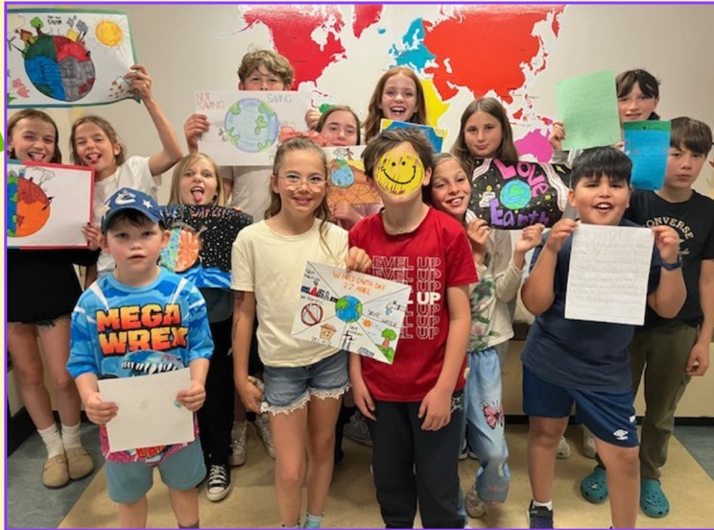
The fine arts program remains an integral part of student life at Drinkwater. Through music, drama, dance, visual art, choir, and performance experiences, students can explore their creativity, discover their strengths, express their ideas, and build confidence. Annual performances highlight the talents of both students and staff and are a source of great pride within our community.
We are fortunate to partner with Nourish Cowichan, which provides access to nutritious food for families who may benefit from additional support. This partnership reflects our commitment to caring for the well-being of the whole child.
At Drinkwater, we remain deeply committed to Truth and Reconciliation. We continue to strengthen our understanding of Indigenous perspectives and ways of knowing, while working to build meaningful connections to the land and local community. This ongoing learning benefits all members of our school community and supports a more inclusive and respectful future.

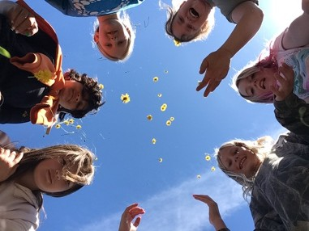
Our Learners

To understand the strengths and next steps for our learners, we continue to Examinemultiple sources of evidence including the Literacy Dashboard,
Oral Reading Fluency (ORF) assessments, Foundation Skills Assessment (FSA) results, classroom-based assessments, report card data, and daily observations of student learning. These data sources help us identify trends and help us respond to their needs with targeted, evidence-informed instruction.
This year, our literacy results demonstrated significant growth across the school. Through our continued commitment to explicit instruction, flexible literacy groupings, and responsive intervention, students showed increased oral reading fluency at every grade level. Growth ranged from 10–20% in many intermediate grades and exceeded 40% in Grade3. Our grade 2 students showed significant improvement, with average oral reading fluency increasing from 25 words per minute to 54 words per minute. Several students demonstrated accelerated growth, and a number of students achieved performance levels exceeding grade-level expectations by the end of the year.
The data suggests that classroom instruction, literacy groups, and targeted literacy interventions were effective in supporting student reading development and student achievement. Many students who entered the year performing below expectations demonstrated steady growth and moved closer to, or achieved, grade-level proficiency.

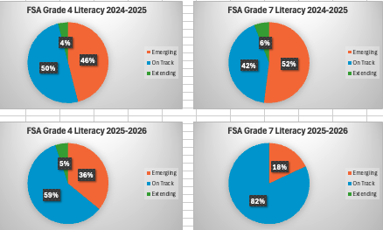
FSA: LITERACY
The Foundation Skills Assessment (FSA) results further reinforce this progress. In literacy, the percentage of students identified as Emerging decreased significantly at both Grade 4 and Grade 7, while the percentage of students meeting expectations increased. These results indicate that we are beginning to close achievement gaps and that our focus on targeted instruction and collaborative planning is improving outcomes for learners.

FSA: NUMERACY
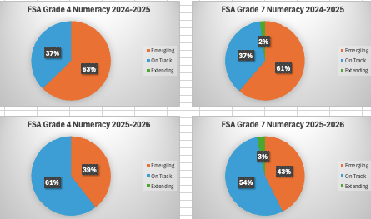
Numeracy remains an important area of focus for our school. Although FSA results indicate improvement in both Grade 4 and Grade 7 numeracy achievement, a significant number of students continue to be identified as Emerging in foundational numeracy skills. This data highlights the need to continue strengthening students' number sense, fact fluency, mathematical reasoning, and problem-solving abilities through targeted, responsive instruction. This is one of the key areas identified by staff to be working on during our Professional Learning Community times.

SENSE OF BLENONG:
Our learners continue to demonstrate the qualities that make Drinkwater a special place. Students show a strong sense of belonging and connection to one another, their teachers, and the broader school community. They are caring, inclusive, and supportive of each other. Empathy, collaboration, and kindness are visible throughout classrooms, on the playground, and during school-wide activities. Learners are curious about the world around them and thrive when provided opportunities to learn together, solve problems, and engage with authentic learning experiences.

While our students continue to develop socially and emotionally, staff continue to observe a growing need for explicit instruction in self-regulation, resilience, healthy relationships, and emotional well-being. Increasing student needs, family requests for support, counselling referrals, and the complexity of social interactions reinforce the importance of maintaining a strong focus on social-emotional learning. We remain committed to helping students build the skills necessary to manage emotions, solve problems, and maintain positive relationships with others.

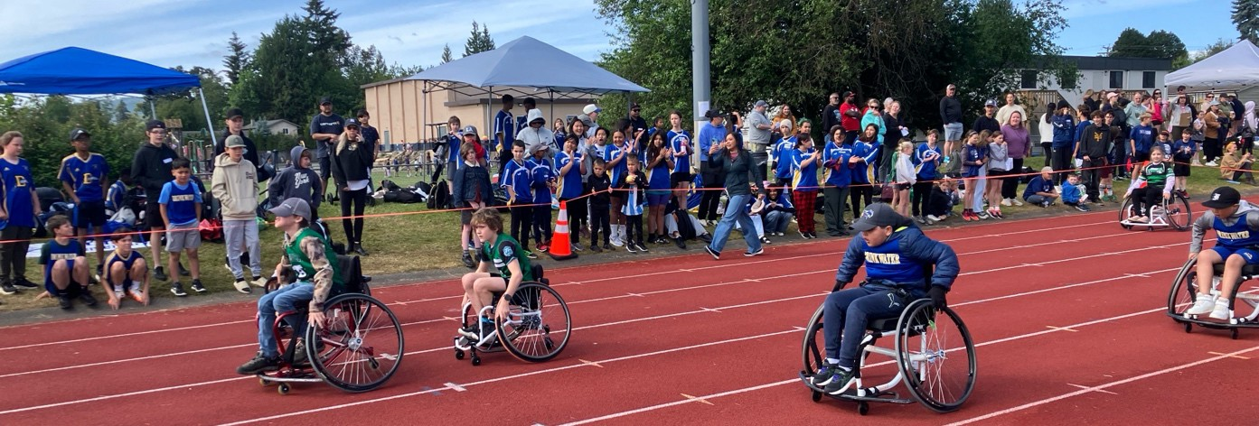
As we move forward, we will build on the success of our literacy work while continuing to deepen our collective understanding of effective numeracy practices and support the social-emotional well-being of all learners. Our goal is to ensure every student feels connected, capable, and successful both academically and personally.

Our Goals
LITERACY GOAL
Our literacy focus continues to build on recent gains in reading fluency while expanding students’ skills in writing, comprehension, and oral language. As a school community, we are committed to strengthening students’ oral reading fluency and developing deeper, more comprehensive comprehension skills across all grade levels. Alongside this, we are prioritizing the growth of student writing through increased writing stamina, improved sentence structure, and opportunities to communicate ideas clearly and effectively. By supporting both oral and written expression, we aim to build confident, capable communicators who can engage thoughtfully with text and share their thinking with clarity.
STRATEGIES/ACTIONS:
- Use flexible grouping to provide targeted literacy instruction
- Strengthen oral language development across all grade levels
- Integrate Indigenous perspectives, storytelling, and ways of knowing into literacy instruction
- Explicitly teach comprehension strategies
- Use collaborative learning to support thinking and communication
- Provide targeted, responsive instruction based on formative assessment
- Collaborate as a staff to ensure consistent literacy practices
EVIDENCE:
- District screening tools and classroom-based assessments
- Foundation Skills Assessment (FSA)
- Student work samples (reading, writing, oral language)
- Student voice (self-assessments, reflections)
- Ongoing staff discussions and collective monitoring of student progress

NUMERACY GOAL
Our goal is to strengthen students’ foundational numeracy skills by focusing on the development of efficient, flexible thinking and improved fact fluency. As a school community, we are committed to supporting students in building automaticity with basic facts, allowing them to engage more confidently in problem-solving and higher-level mathematical reasoning. Through targeted instruction and responsive practices, we will continue to deepen students’ understanding of number relationships, enhance their ability to apply strategies across contexts, and foster perseverance and confidence in solving complex problems.

STRATEGIES/ACTIONS:
- Develop fact fluency through consistent, school-wide practice
- Strengthen number sense and flexible thinking
- Embed problem-solving across numeracy instruction
- Use targeted, responsive instruction based on assessment data
- Foster student confidence, engagement, and perseverance
- Collaborate as a staff to align numeracy practices

EVIDENCE:
- Student learning summaries and classroom-based assessments
- District and school numeracy screeners
- Foundation Skills Assessment (FSA)
- Student work samples demonstrating problem-solving and reasoning
- Student voice and participation in mathematical thinking

SOCIAL-EMOTIONAL GOAL
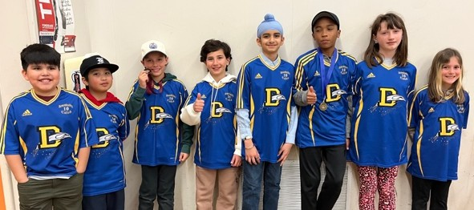
Our goal is to support students in developing strong social-emotional skills that enable them to understand and manage their emotions, make positive choices, and build respectful, caring relationships with others. As a school community, we are committed to explicitly teaching strategies for self-regulation, healthy interactions, and emotional awareness. We aim to empower students to take increasing ownership of their well-being and to approach challenges with confidence, resilience, and a sense of belonging. By fostering safe, inclusive, and supportive learning environments, we strive to ensure that every student feels calm, connected, and ready to learn.

STRATEGIES/ACTIONS:
- Provide explicit, school-wide social-emotional learning (SEL) instruction, using progams such as Open Parachute
- Encourage reflective practices and the inclusion of Indigenous perspectives that emphasize connection, balance, and community
- Strengthen student self-regulation and coping strategies
- Foster positive relationships and inclusive learning environments
- Maintain safe, predictable, and strengths-based classrooms
- Support student voice and ownership of well-being
- Collaborate with staff and families to ensure consistent support

EVIDENCE:
- Improved self-regulation and emotional awareness
- Positive peer relationships and reduced conflict
- Strong sense of belonging and safety (student surveys, student voice and anecdotal data)
- Increased confidence and resilience
- Consistent use of SEL strategies and common language
- Collaborative and responsive staff practices
- Classroom observations and anecdotal data

Student Voice at Drinkwater Elementary
When asked what makes Drinkwater special, our students consistently highlighted the friendships, caring teachers, and strong sense of belonging that make our school a welcoming place to learn and grow. They appreciate teachers who are kind, supportive, and willing to help when learning becomes challenging. Students spoke enthusiastically about their learning experiences, including developing their reading and math skills, exploring ancient civilizations and local government, conducting science fair experiments, and participating in sports, art, music, and memorable field trips. They take pride in being Dolphins and describe their school community as inclusive, friendly, and supportive, where students help one another, celebrate individual differences, and look out for younger learners. Recess, physical education, and opportunities to connect with friends are especially valued, reflecting the importance of relationships and play in their school experience. Students also recognize the importance of school traditions and celebrations, including Orange Shirt Day, Pink Shirt Day, musical performances, school fairs, and Grade 7 graduation, which bring the community together and build school spirit. Importantly, our students are thoughtful about how their school can continue to improve. They identified opportunities to strengthen kindness, respectful language, inclusion, positive conflict resolution, and care for our shared environment. Their voices reflect a school community where relationships matter, learning is celebrated, and students are developing a growing sense of responsibility for themselves, one another, and their school. Above all, our students want Drinkwater to be a place where everyone feels welcomed, included, and proud to be a Dolphin.

