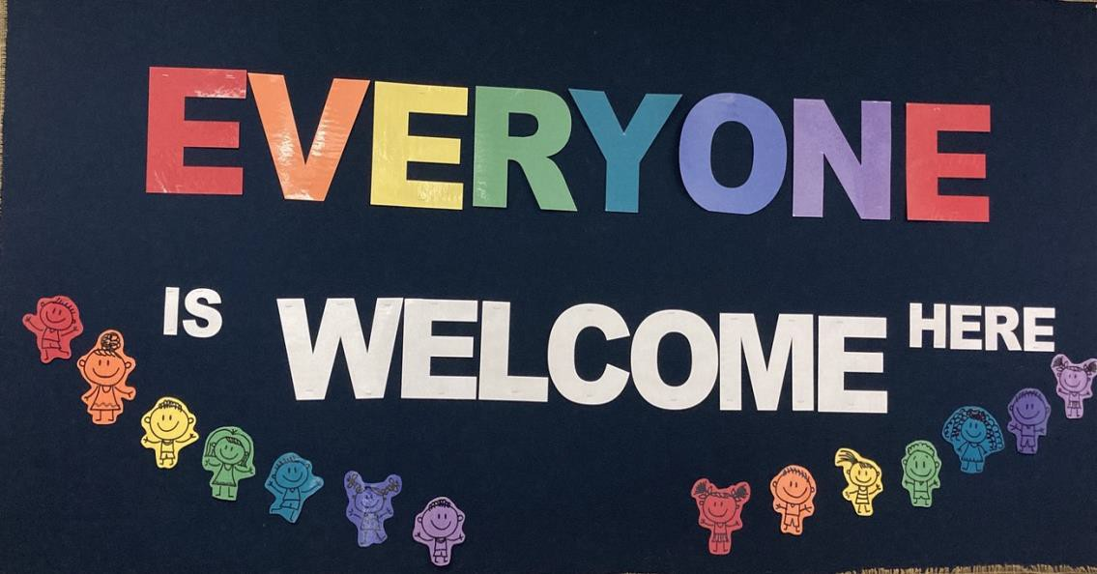
Drinkwater Elementary
Scoop
Weekly Newsletter – vol. 2
Upcoming Dates:

Oct. 19 Picture Day!

Oct. 21
Great BC Shake Out
10:21 am

Oct. 22 Pro-D Day No school

Oct. 27
PLC (Professional Learning Community )
2 hr. early dismissal (12:15 pm)

Nov. 11, 2021
Remembance Day – no school

October 12, 2021

October
October is a busy month here at Drinkwater. We have boys soccer and girls field hockey teams. Both teams will be participating in the district tournaments. Permission forms are coming home.
We are excited to have Naomi come back work with all of our students in K- 7 on Lacrosse skills. This will be happening over the next few weeks.
Our K-2 classes will be taking a school bus safety program where they will learn skills such as loading and unloading the bus safely, and how to be safe bus riders. This will be taking place the last two weeks of October.
Please continue to perform the daily health checks before sending your children to school.

WEEKLY NEWSLETTER - OCTOBER 2021
Parking and Student Safety
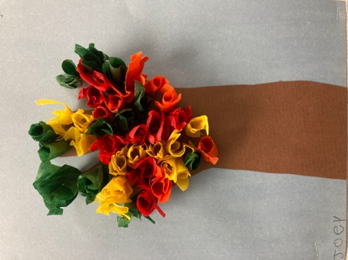
Just a gentle reminder that the parking lot in front of the school is for STAFF only
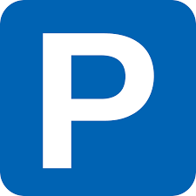
Families can park their vehicles in the gravel parking lot just beside the forest area. In our endeavor to keep your children safe, pleas
remember to not do u-turns, stop and park in the red zones on the road, or block our neighbours driveways.

Verification Forms

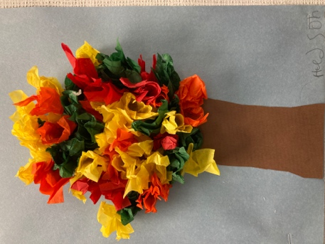
Thank you to all of our families who have returned the verificaton forms. If you have not already done so, it is not too late.

FSA

FSA’s are beginning this week. This assessment is for all grade 4’s and 7’s in the Province. This is an assessment for literacy and numeracy.

Picture Day

Picture Day is happening on October 19th. Photographers will be taking a picture of every child. Within 2-3 weeks a proof sheet will come home for you to be able to order on line, or you can do a paper order through the school.

Lunches / Water Bottles
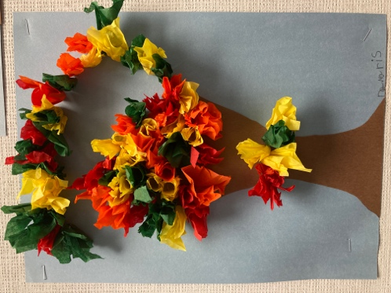
Drinkwater Elementary is working hard to be a garbage free school. Please try and use re-usable containers and wraps for children’s lunches. We are also encouraging the use of water bottles (since our fountains are open once again) over juice, pop, and other sugary drinks.

Grade 6 Immunizations

Immunization forms are coming home today. Please return them by Friday.

Communicating Student Learning (CSL)
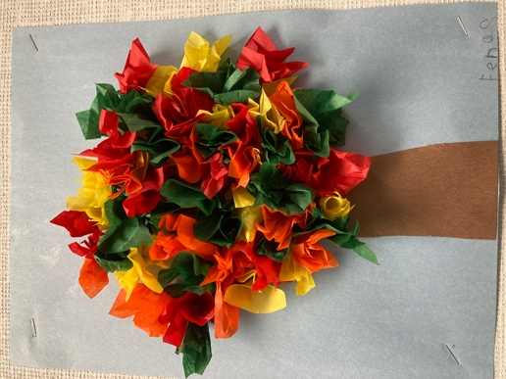
You will be receiving on going communication regarding your child throughout the year, as well as receiving 2 learning summaries – 1 in late January/early February and 1 at the end of June. On-going communication will look different for every teacher. It will include phone calls, face to face conversations, emails, messages through freshgrade or Ed Inform, as well as points of progress. Please feel free to connect with the classroom teacher for a meeting if you have any questions or concerns throughout the school year.
You should have already heard from your child’s classroom teacher about CSL. If you have not, please reach out.

Lost and Found
Can you believe we are already beginning to see a full Lost and Found bin? Please remind your children to be collecting their jackets/sweatshirts/ etc. off of the school grounds at the end of the day. If you find your child(ren) are losing their clothing…please feel free to come and check out the bins outside of the library.

Health and Safety

Please remember to send your child with a mask.
As a reminder, here are the guidelines around returning to school after an illness:

Students, staff or other adults should stay at home when sick, as this is one of the most important ways to reduce the introduction to and the spread of COVID-19 in schools. The following resources provide guidance regarding specific symptoms of illness:

Parents/caregivers and students can use the K-12 Health Check app.
Staff and other adults can refer to BCCDC’s “When to get tested for COVID-19”.

Staff, students and parents/caregivers can also use the BCCDC online Self-Assessment Tool, call 8-1-1 or their health care provider.

When a staff, student or other adult can return to school depends on the type of symptoms they experienced (as indicated in the K-12 Health Check app and BCCDC “When to get tested for COVID-19” resource), if a COVID- 19 test is recommended, and the type of illness they had (e.g. COVID-19 or other illness).

Students and staff who experience symptoms consistent with a previously diagnosed health condition (e.g. seasonal allergies) can continue to attend school when they are experiencing these symptoms as normal. They do not require re-assessment by a health-care provider and should not be required to provide a health-care provider note. If they experience any new or unexplained symptoms, they should seek assessment by a health- care provider.

Students or staff may still attend school if a member of their household develops new symptoms of illness, provided the student/staff has no symptoms themselves. If the household member tests positive for COVID-19, public health will advise the asymptomatic student/staff on self-isolation and when they may return to school.

School Goal
Our school goal is to improve literacy achievement across the grades.
As a school, we are looking at how we can best support all of our learners in literacy. This past year has been a year of learning for our staff as well as our students. We are learning about the Science of Reading and how understanding this science will help us in supporting our learners.

What is the Science of reading?

Learning to read is such an essential skill to not only find success in school and to thrive in society, but to also experience the joy that reading brings to life. We want every child to be successful in reading!

We are learning about what research says about how children learn to read, how to make sure every student learns to read, and what to do when a child encounters difficulty in learning to read. The research that we're learning about and implementing is called the Science of Reading.

The "Science of Reading" may seem to be the new buzzwords in education. The Science of Reading is 50 years of scientific research that shows the most effective ways to teach reading. Reading does not occur naturally the way that speech does. The process must be taught. It is a process of building neuro-pathways in the brain that link sounds of speech to written symbols or letters. Some students learn to read in spite of instruction however, many students need instruction based on the Science of Reading.

"The body of work referred to as the "Science of Reading is NOT an ideology, a philosophy, a political agenda, a one-size fits all approach, a program of instruction, nor a specific component of instruction. It is the emerging consensus from many related disciplines, based on literally thousands of studies supported by hundreds of millions of research dollars, conducted across the world in many languages." Dr. Louisa Moats

Stay tuned next week for Scarborough's Reading Rope

PAC News

Don’t forget the PAC is running a “Fundraising with First Aid” – these make great Christmas gifts. All orders are due by October 29th please.

Upcoming fundraisers include: Drinkwater Swag Wear, Purdy’s, and Beef Jerkey!
As always, the PAC sells Panago Pizza coupons. Please connect with Nicole Gollinger if you are interested in purchasing any.

